SMART LIBRARY REQUEST WORKFLOW IN SERVICENOW
Technical Documentation
Subject: ServiceNow Platform Development Project Type: Role-Based Library Management System Institution: Swami Dayananda College of Arts & Science Department: B.Sc. Artificial Intelligence & Machine Learning Academic Year: 2024–2025

1. Project Overview
1.1 Problem Statement
Academic institutions managing library systems manually face several critical challenges:
- Lack of real-time updates on book availability for students
- Inefficient, paper-based approval processes causing delays
- Limited visibility into borrowing patterns and resource usage
- Students unable to check book availability before visiting
- Librarians struggle with tracking requests and maintaining accurate records
To address these challenges, a role-based Library Management System has been implemented on the ServiceNow platform. The system allows students to request books while librarians manage inventory and approve borrow requests. Automated workflows, role-based access controls, and analytics reports ensure a streamlined process for all stakeholders.
1.2 Objective
The objective of this project is to implement a role-based Library Management System in ServiceNow that simplifies the process of borrowing and managing books. The system:
- Allows students to submit borrow requests and track their status in real-time
- Enables librarians to manage the book catalog and approve or reject requests
- Automates book availability updates through Flow Designer workflows
- Enforces proper security through role-based access control (ACLs)
- Provides reporting features such as Most Borrowed Books for resource management
1.3 Business Objectives
The main business objectives of this project are:
- Create a digital library system that reduces manual effort and improves accuracy
- Automate borrow request submission, approvals, and book status updates
- Ensure efficient operations with transparency and faster access to library resources
- Support better decision-making through role-based controls and usage reporting
- Deliver a scalable foundation extensible to other academic services

2. Functional Scope & Stakeholders
2.1 Functional Scope
The Library Management System on ServiceNow provides the following key functions:
Book Management – Librarians can add, update, and maintain book details with status tracking: Available, Issued, Lost, Returned.
Borrow Requests – Students can create and track requests; librarians can approve, reject, or close them.
Workflow Automation – Approval of requests automatically updates book status to Issued.
Role-Based Access – Students have limited access to requests; librarians manage the entire system.
Reporting – Generate insights such as Most Borrowed Books for library usage analysis.
2.2 Stakeholder Mapping
Stakeholder | Role | Access Level
Student | Request books, track borrow status | Create/Read own records
Librarian | Manage catalog, approve/reject requests, generate reports | Full CRUD on Book & Borrow Request
System Administrator | Configure tables, workflows, roles | Platform-level access
Management / Faculty | Use reports for planning and resource allocation | Read-only reports
IT Support Team | Technical support, upgrades, system reliability | Infrastructure access

3. System Architecture & Data Design
3.1 Data Architecture
The system is built on two core custom tables in ServiceNow, linked by a reference relationship.
Book Table (u_book)
Field | Type / Values
Title (Titel) | String – display field
Author | String
ISBN | String
Status | Choice: Available (default), Issued, Lost
Borrow Request Table (u_borrow_request)
Field | Type / Reference
Requested By | Reference → User [sys_user]
Book | Reference → Book [u_book] (filtered: Status = Available)
Request Date | Date/Time
Status | Choice: Requested (default), Approved, Rejected, Returned
3.2 Table Relationship
The Borrow Request table holds a Reference field pointing to the Book table (u_book). A Borrow Request related list is exposed on the Book form, providing a full view of all borrow transactions for each book from the librarian's perspective.
3.3 Reference Qualifier (Availability Filter)
A Reference Qualifier is configured on the Book field in the Borrow Request table to display only books where Status = Available. This prevents students from requesting already-issued or lost books, reducing errors and duplicate entries automatically.

4. Implementation – Phase-by-Phase Execution
4.1 Phase 1: Requirement Analysis & Planning
Planning covered the full system design including role definitions, table structures, field configurations, workflow logic, access control rules, and test case design. The execution roadmap was defined across 10 milestones.
Milestone | Description | Status
1 – Create Roles | Define student and librarian roles with proper access separation | Completed
2 – Create Tables | Build u_book and u_borrow_request tables with relationships | Completed
3 – Book Fields | Add Title, Author, ISBN, Status fields; configure choice values | Completed
4 – Borrow Request Fields | Add Requested By, Book, Request Date, Status fields | Completed
5 – Related List | Show Borrow Requests as related list on Book form | Completed
6 – Reference Qualifier | Restrict book selection to Status = Available only | Completed
7 – Flow Designer | Automate approval → book issuance → email notification | Completed
8 – UI Policy | Lock fields post-approval; make Return Date mandatory on issuance | Completed
9 – ACLs | Define role-based access control for both tables | Completed
10 – Report | Create Most Borrowed Books report grouped by Book with Count | Completed
4.2 Phase 2: Backend Configuration
Step 1 – Role Creation
Two roles were created under User Administration → Roles:
- librarian – Manages book catalog, approves requests, accesses all records
- student – Can submit and track own borrow requests only
Step 2 – Table Creation
- Navigate to All → System Definition → Tables
- Click New → Label: Book → Submit (creates u_book)
- Click New → Label: Borrow Request → Submit (creates u_borrow_request)
- Verify both tables appear in the Tables module
Step 3 – Adding Fields to Book Table
Fields added to u_book via the Columns (Dictionary) related list:
- Title – Type: String (display field)
- Author – Type: String
- ISBN – Type: String
- Status – Type: Choice with values: Available (default), Issued, Lost
Step 4 – Adding Fields to Borrow Request Table
Fields added to u_borrow_request via the Columns (Dictionary) related list:
- Requested By – Type: Reference → User [sys_user]
- Book – Type: Reference → Book [u_book]
- Request Date – Type: Date/Time
- Status – Type: Choice with values: Requested (default), Approved, Rejected, Returned
Step 5 – Related List Configuration
The Borrow Request related list was added to the Book form via Configure → Related Lists. This allows librarians to see all borrow history and pending requests directly from the Book record.
Step 6 – Reference Qualifier Setup
- Open the Book field in the Borrow Request table (Dictionary)
- Go to Advanced View → Reference Qualifier section
- Select Simple type
- Set condition: Status is Available
- Click Update to save
4.3 Phase 3: Flow Designer – Approval Workflow
The Borrow Request Approval Flow was created in Flow Designer to automate the full borrow lifecycle:
Flow Step | Configuration
Trigger | Created or Updated on Borrow Request where Status = Requested
Action 1 – Approval | Ask for Approval with Approvers = Role: librarian
On Approve | Continue to next actions in flow
On Reject | Update Borrow Request Status = Rejected
Action 2 – Issue Book | Update Record: Book [u_book] → Status = Issued (via Current.Book)
Action 3 – Update Request | Update Record: Borrow Request → Status = Approved
Action 4 – Notify | Send Email to Requested By with approval confirmation
Steps to create the flow:
- Navigate to All → Flow Designer → New → Flow
- Name: Borrow Request Approval Flow → Submit
- Add Trigger: Created or Updated → Table: Borrow Request → Condition: Status = Requested
- Add Action: Ask for Approval → Approvers: Role: librarian
- On Approve path: Add Action → Update Record → Book [u_book] → Status = Issued
- Add Action → Update Record → Borrow Request → Status = Approved
- Add Action → Send Email → To: Requested By → Subject: Your Borrow Request has been Approved
- Click Save → Activate
4.4 UI Policy Configuration
A UI Policy was created on the Borrow Request table:
Steps:
- Navigate to All → System UI → UI Policies → New
- Table: Borrow Request [u_borrow_request]
- Short Description: Make Return Date mandatory when Issued
- Condition: Status = Issued
- In UI Policy Actions: Field = Return Date → Mandatory = True, Visible = True
- Submit
Additional policy: When Status = Approved → Book and Requested By fields set to Read Only = True.

5. Access Control (Security)
5.1 ACL Configuration
Access Control Rules were configured under System Security → Access Control (ACL):
Table | Operation | Allowed Roles
Book (u_book) | Read | Student, Librarian
Book (u_book) | Write | Librarian
Book (u_book) | Delete | Librarian
Borrow Request (u_borrow_request) | Create | Student
Borrow Request (u_borrow_request) | Read | Student, Librarian
Borrow Request (u_borrow_request) | Write | Librarian
Borrow Request (u_borrow_request) | Delete | Librarian
Result: Students can only create and read their own borrow requests. Librarians have full CRUD access across both tables.

6. Reporting
6.1 Most Borrowed Books Report
Steps to create:
- Navigate to All → Reports → View / Run → New
- Name: Most Borrowed Books
- Source Type: Table → Borrow Request [u_borrow_request]
- Type: Bar Chart
- Group By: Book
- Aggregate: Count
- Filter: Status = Approved
- Click Run → Save → Share with roles: student, librarian
The report provides library administrators with actionable insights into resource usage, enabling better procurement decisions and identifying high-demand titles.

7. Testing & Validation
7.1 Testing Approach
Test Area | Validation Performed
Flow Execution | Verified trigger conditions, approval routing, book status update, and email notification
Reference Qualifier | Confirmed only Available books appear in Borrow Request book selector
UI Policy | Confirmed Return Date becomes mandatory on Status = Issued; fields locked on Approved
Access Control | Students restricted to own records; librarians have full access as designed
Report Accuracy | Verified Most Borrowed Books only counts Approved/Issued borrow requests
7.2 Troubleshooting
- Flow execution logs confirmed end-to-end path via Execution Details in Flow Designer
- Reference Qualifier corrected to properly filter Available books only
- UI Policy visibility and mandatory settings verified across portal and platform views
- ACL conditions adjusted to correctly restrict student access to own records
- Report grouping fixed to display correct book titles with accurate counts

8. Innovation & Future Enhancements
8.1 Key Innovations
- End-to-End Automation: Integrated custom tables, Flow Designer, and approval workflows to eliminate manual tracking entirely
- Optimized Request Handling: Reference qualifiers prevent duplicate or invalid borrow entries at the data entry stage
- Dynamic Form Behavior: UI Policies adapt form fields contextually based on request status
- Maintainability & Scalability: Built entirely on out-of-the-box ServiceNow features for easy maintenance and future expansion

8.2 Future Enhancements
- Auto-notifications for overdue books and return reminders via email/SMS
- Integration with external library systems or digital catalog APIs
- Enhanced reporting dashboards – borrow frequency trends, student activity, overdue analysis
- Expansion to other academic services: lab equipment requests, study room booking, digital resource access
- Mobile portal optimization for student self-service

9.screenshot
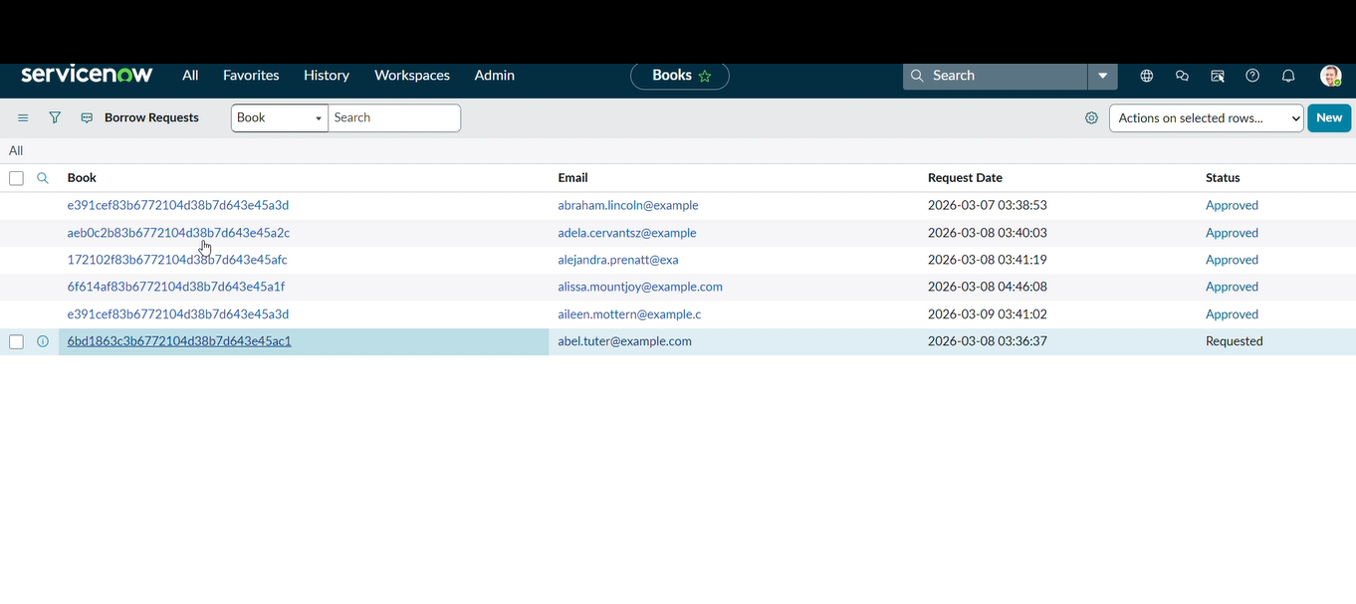

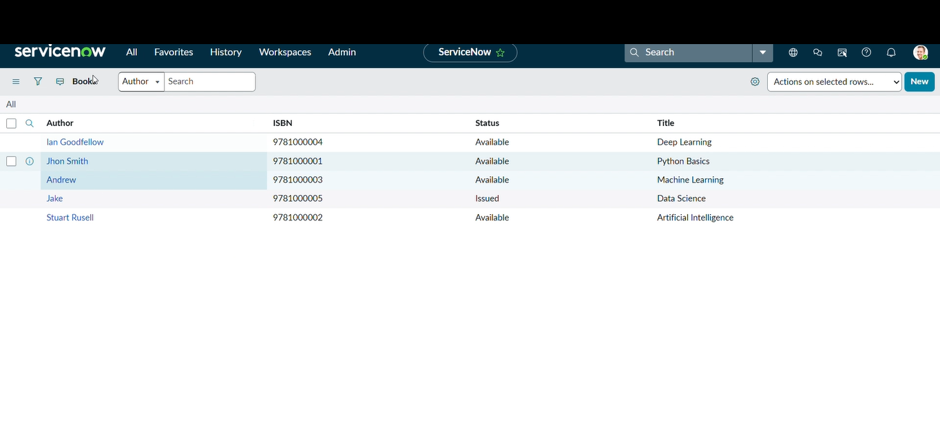

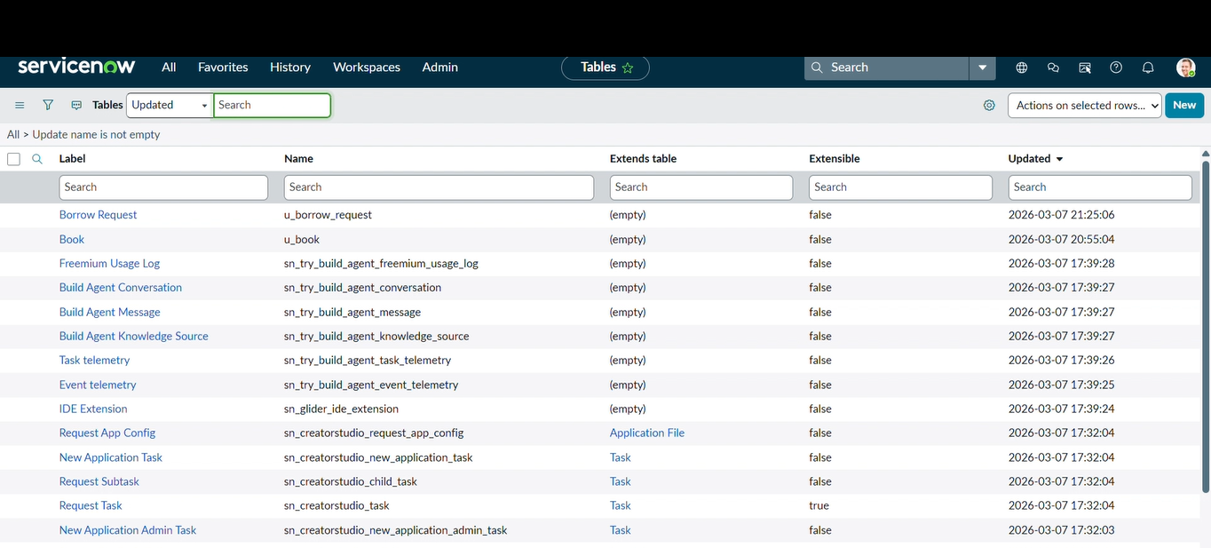

Output:
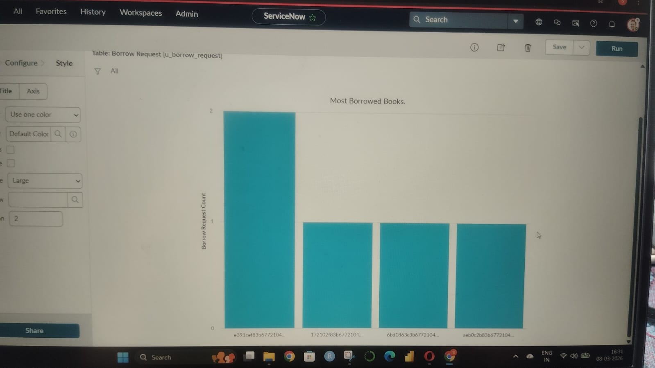

10. Conclusion
The Smart Library Request Workflow project successfully streamlined the process of borrowing and managing books within ServiceNow by integrating role-based access, automated approvals, and dynamic workflows. Key outcomes achieved:
- Students can easily submit borrow requests and track their status in real-time
- Librarians efficiently review, approve, and issue books with proper data validations
- Automated Flow Designer workflows eliminate manual processing and reduce errors
- Role-based ACLs ensure data security and proper access boundaries
- UI Policies maintain form integrity and improve the user experience for both roles
- Reporting features provide actionable insights for resource planning and management
The solution delivers a scalable, maintainable foundation built entirely on native ServiceNow capabilities, ready to be extended to broader academic services.

